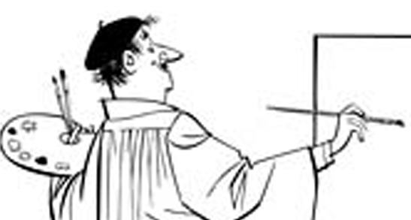October 21, 2011

Greetings Parents - from Field Art!

During this first few weeks of the term, your 6th grader has begun to understand that art is all around and that artists see the world through a special lens. To model artists, we viewed familiar scenes, with this same special lens - the elements and principles of design lens.

This term your student will create his/her own elements and principles photo slide show with digital images which I hope can be taken at home before Thursday - with the family digital camera. Collected images can be downloaded and transferred onto personal USB drives and brought back to school for presentation creation this Thursday through Monday. Students who do not have access to a camera at home should collect images manually from magazines or newspapers.

I ask that if it is at all possible, you please allow your child to take pictures this week with the family camera. Feel free to call or email me with any questions you might have.

Thanks very much,

Paula Delehanty
pdelehanty@district31.net

LINE

COLOR

SHAPE

VALUE

TEXTURE

SPACE

FORM

Balance

Unity

Movement

Pattern

Variety

Emphasis

Rhythm

Proportion

